**DAILY ONLINE ACTIVITIES SUMMARY**

|  |  |  |  |  |  |  |  |
| --- | --- | --- | --- | --- | --- | --- | --- |
| **Date:** | **18/06/2020** | | | | **Name:** | **Sinchana K N** | |
| **Sem & Sec** | **IV sem & B section** | | | | **USN:** | **4AL18CS083** | |
| **Online Test Summary** | | | | | | | |
| **Subject** | | **-** | | | | | |
| **Max. Marks** | | **30** | | **Score** | | **-** | |
| **Certification Course Summary** | | | | | | | |
| **Course** | **Introduction to Information Security** | | | | | | |
| **Certificate Provider** | | | **Greatlearning academy** | **Duration** | | | **5.5 hours** |
| **Coding Challenges** | | | | | | | |
| **Problem Statement1:** Write a C Program to generate first N Magic Numbers.  **Problem Statement2:**Find the smallest positive integer value that cannot be represented as sum of any subset of a given array sorted in ascending order. | | | | | | | |
| **Status: Executed** | | | | | | | |
| **Uploaded the report in Github** | | | | **YES** | | | |
| **If yes Repository name** | | | | **https://github.com/acchu1234sinchana/Lockdown_coding1** | | | |
| **Uploaded the report in slack** | | | | **YES** | | | |

Online Test Summary: No internals conducted today.

Online Certification Course Summary: Today I have learnt about Introduction to Software Security and also about its security goals and its implementation.

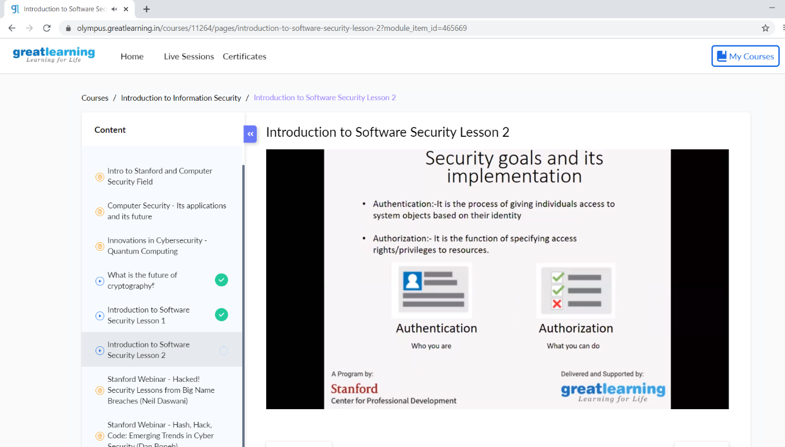

This is the snap shot of today’s session.

Online Coding Summary: **Today I had received one program from prof. Venkatesh CSE Dept.The program is mentioned above in the coding challenges(pg.01). I have also uploaded it to my Github repository.**

